**Sentiment Analysis of Product Review**

Python Data Analysis Project

**Introduction :**

This project involves analyzing a dataset of customer reviews to understand sentiments expressed by users about products. Sentiment analysis is a key technique in natural language processing (NLP) and data analysis, used to extract subjective information from textual data. The goal is to uncover insights from the reviews and build models that can predict sentiments (positive, negative, or neutral).

**Dataset Overview:**

The provided dataset contains information about customer reviews for products in the "Books" category. Key columns include:

1. **Review Text**: Textual feedback from customers, the primary source for sentiment analysis.
2. **Sentiment**: Pre-labelled sentiment for each review (positive, negative, or neutral), useful for supervised machine learning.
3. **Star Rating**: Numeric rating (1–5 stars), which might correlate with sentiment.
4. **Votes (Helpful/Total)**: Indicators of review credibility and popularity.
5. **Verified Purchase**: Distinguishes between verified and non-verified reviews.
6. **Review Date**: Useful for trend analysis over time.

**Importance of the Analysis:**

1. **Customer Feedback**: Understanding sentiments can help businesses evaluate customer satisfaction and product quality.
2. **Market Trends**: Insights from reviews can guide product improvement and customer support strategies.
3. **Automation**: A sentiment classifier can streamline the evaluation of large volumes of reviews, saving time and resources.
4. **Import and Setup : -** 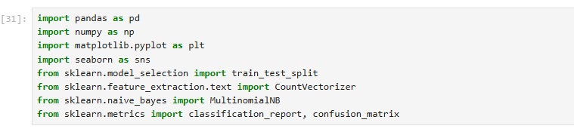
5. **Load Dataset : -** 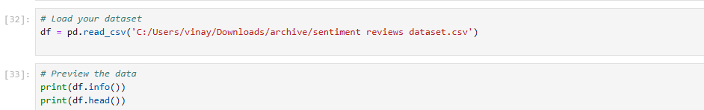 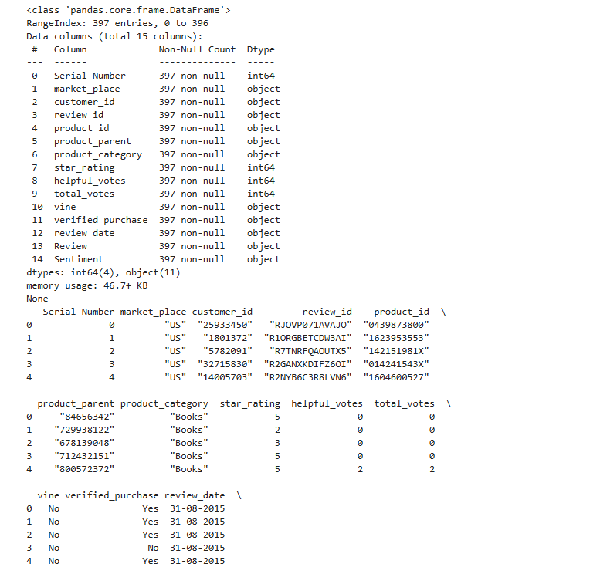 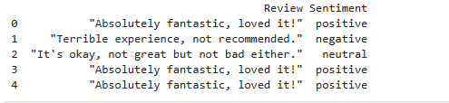
6. **Visualizations :-**

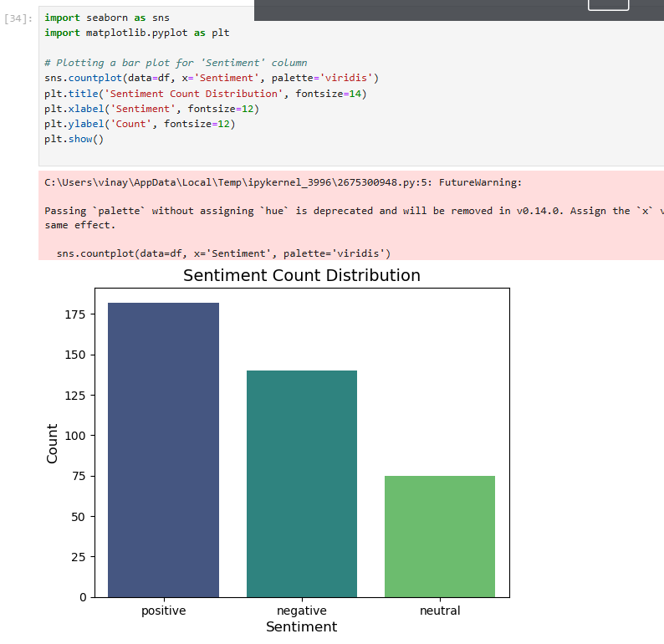

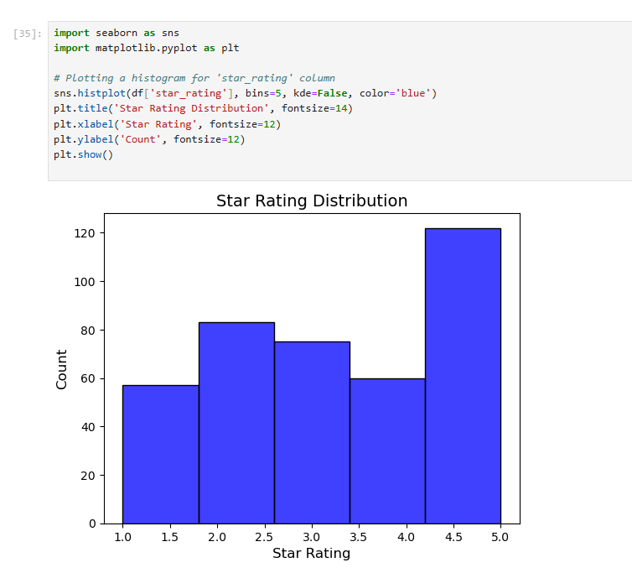 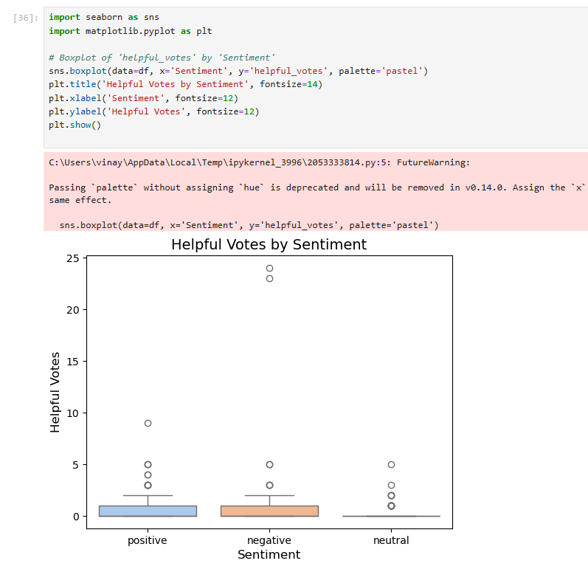 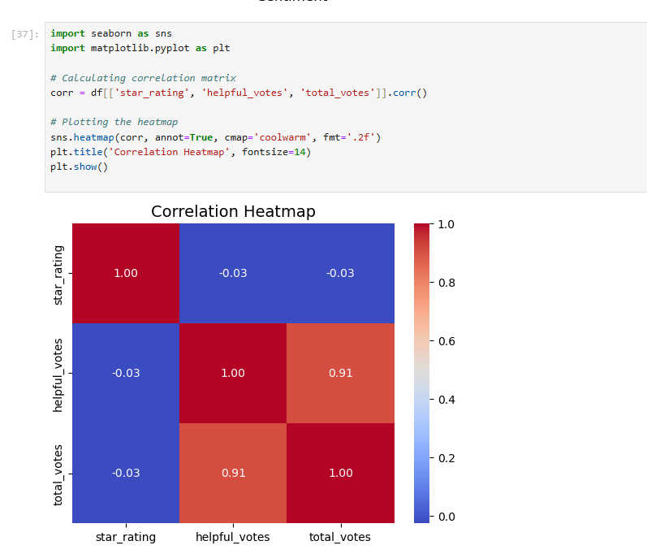 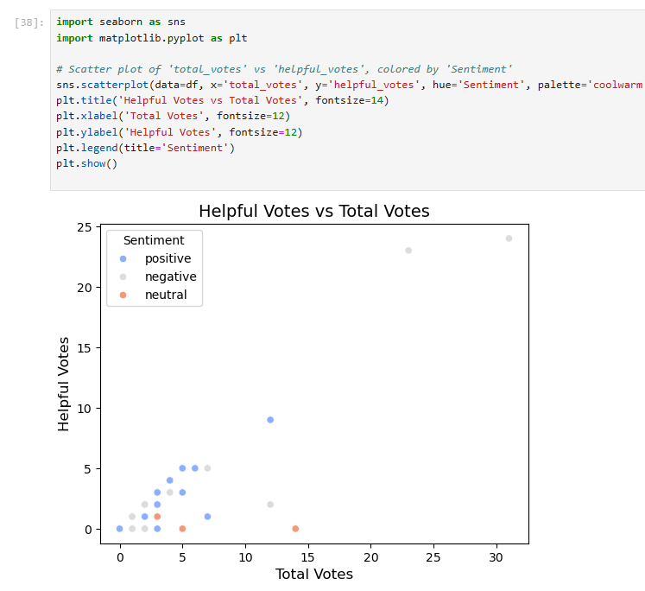 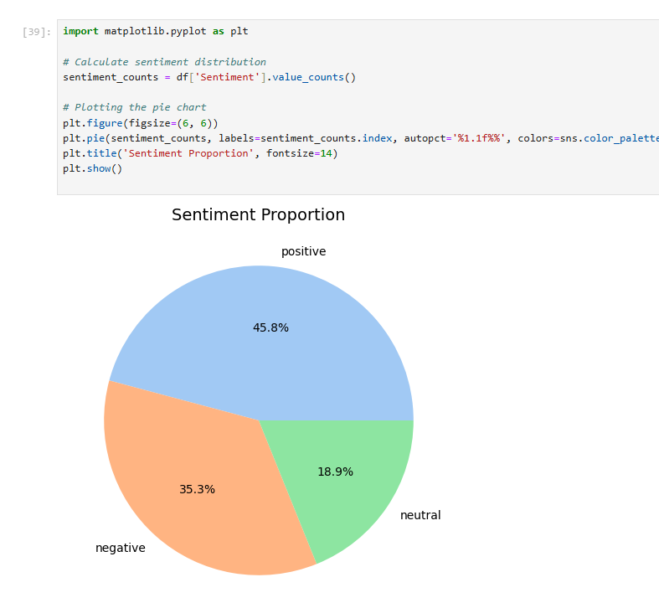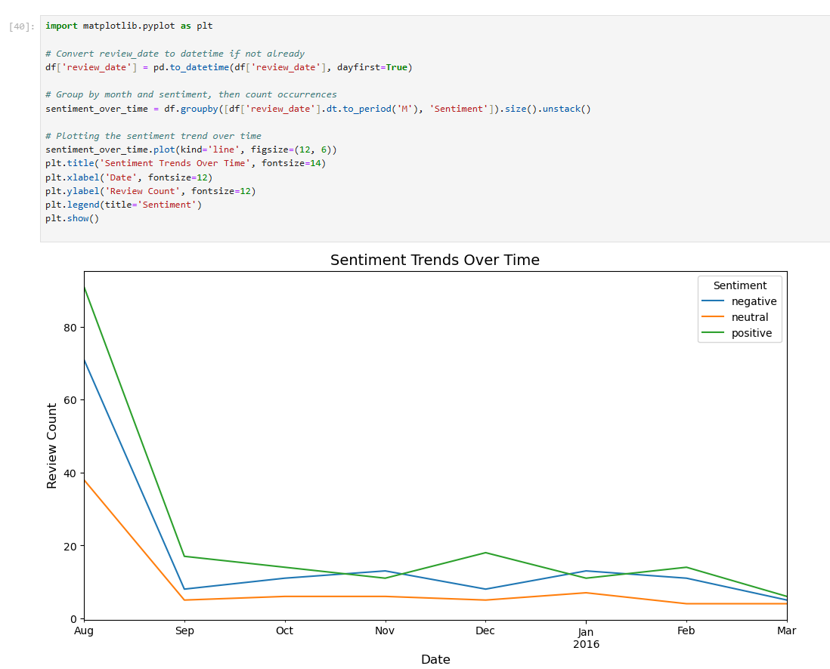

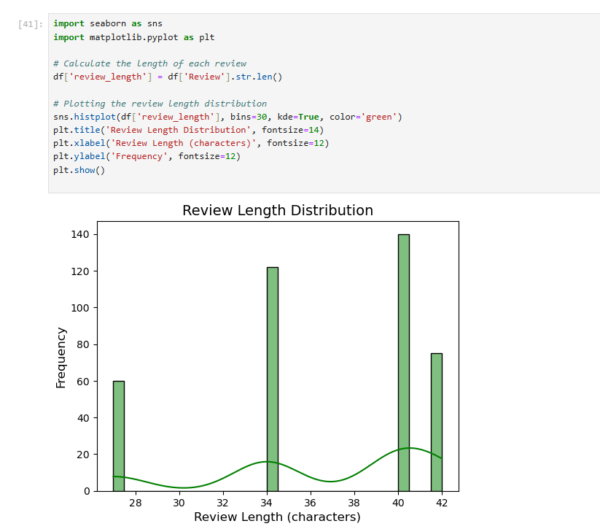 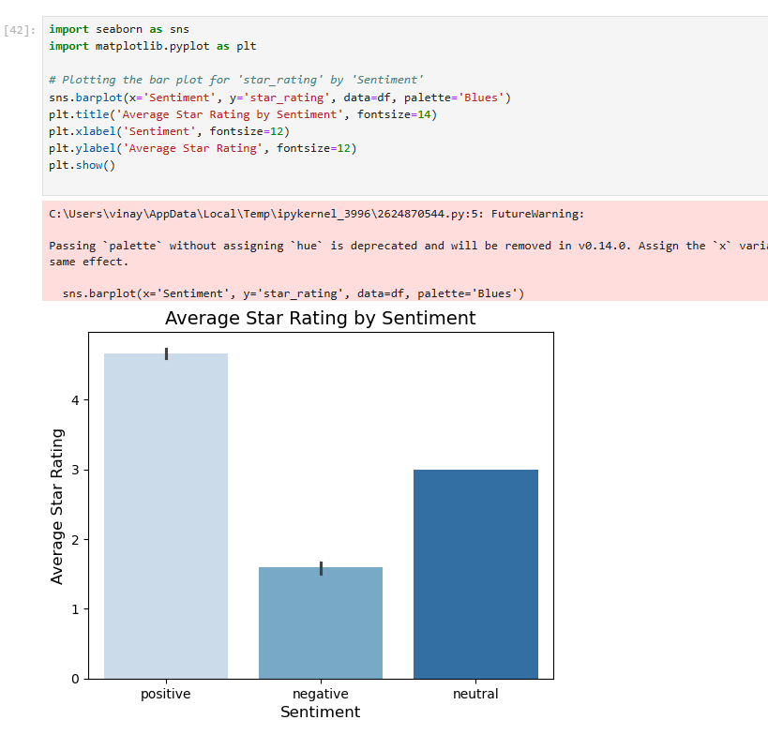

1. **Process the data :-** 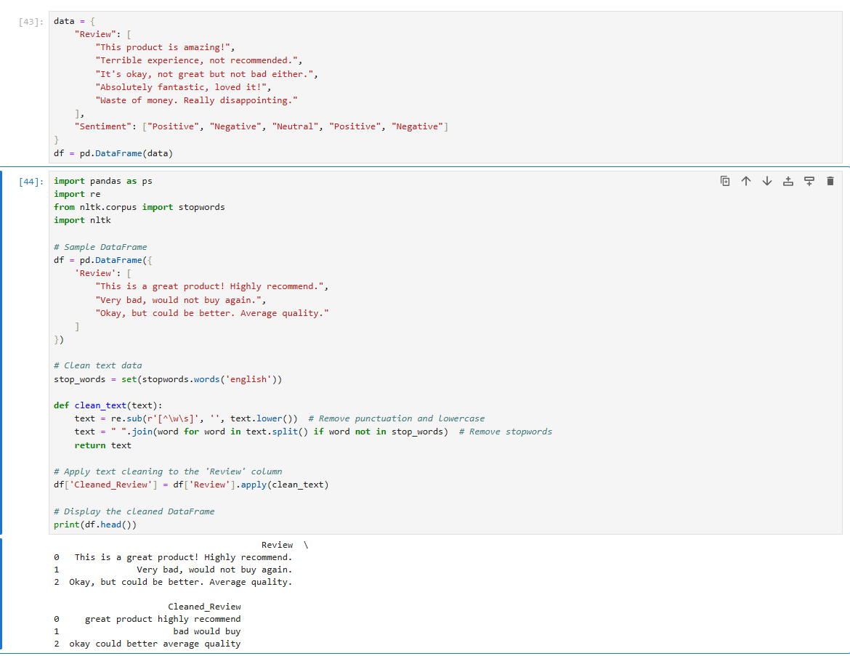
2. **Evaluate the Model :-** 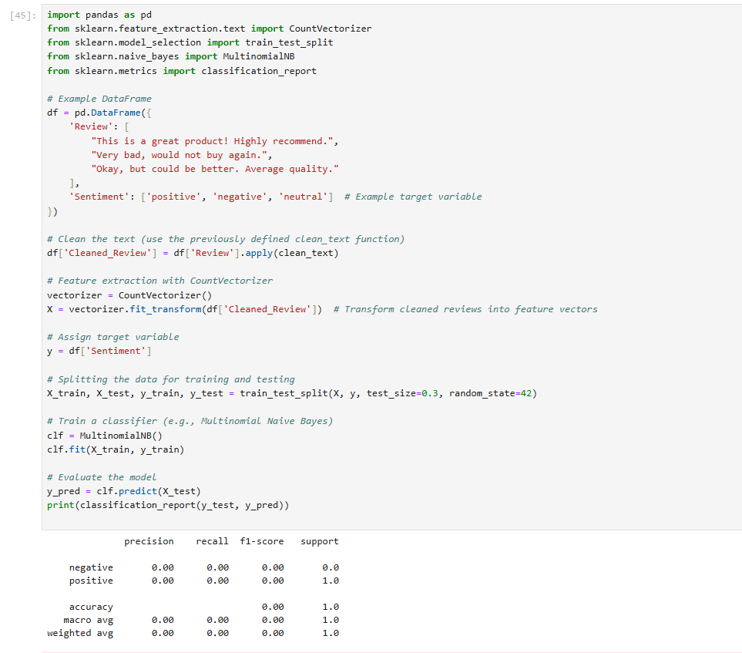

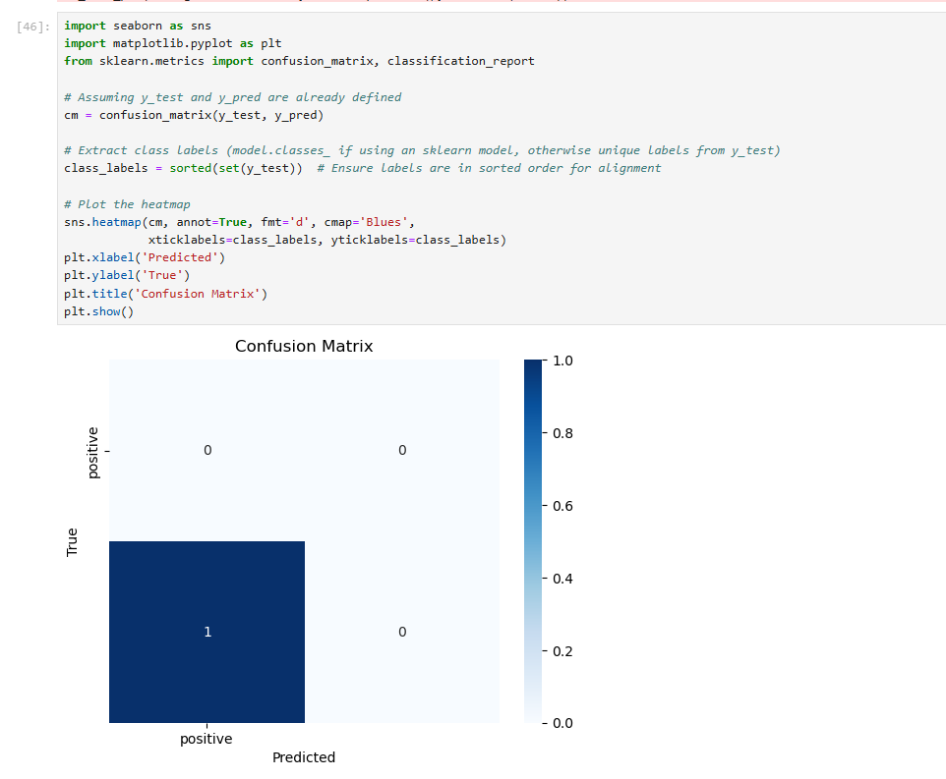

1. 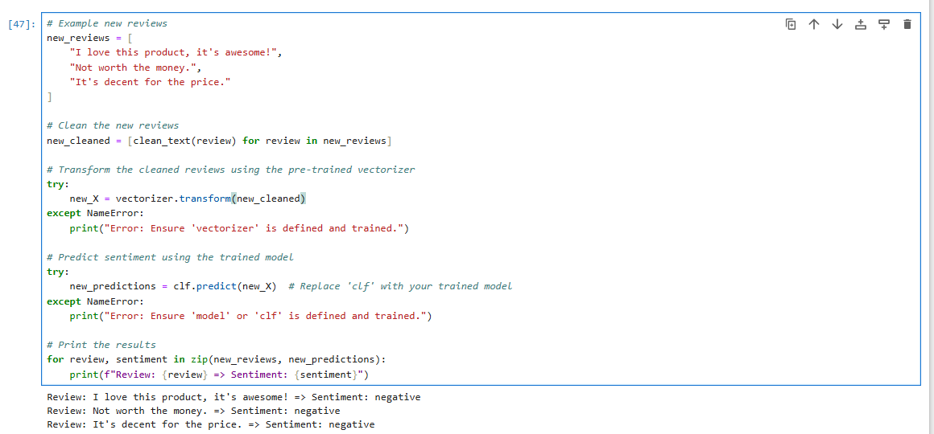**Test The Model With New Input :-**
2. **Insights :**

The sentiment analysis of customer reviews reveals valuable trends about customer satisfaction. If the majority of the reviews are positive, it indicates overall customer contentment with the product or service. On the other hand, a high volume of negative sentiment suggests dissatisfaction, which could be due to issues like poor product quality, customer service, or unmet expectations. By analyzing the average star ratings, we can further correlate how sentiment aligns with numerical ratings, providing a clearer picture of customer experiences. Positive sentiment is typically associated with higher star ratings, while negative sentiments tend to correlate with lower scores. This insight can guide product improvements, customer engagement strategies, and marketing efforts, emphasizing aspects of the product that resonate with customers and addressing pain points that cause frustration.

Additionally, reviewing sentiment distribution across different product categories can reveal more targeted insights. For example, a specific product category may receive more negative feedback due to inherent flaws, while others may enjoy positive reviews for their features or quality. This information is crucial for refining the product lineup, focusing resources on improving products with lower ratings, and ensuring better satisfaction across all product ranges. By tracking sentiment trends over time, it is possible to detect if customer satisfaction is improving or declining, enabling proactive adjustments to product offerings and marketing strategies.

**Summary**

The sentiment analysis of customer reviews provides key insights into customer satisfaction and product performance. Positive sentiment and high star ratings indicate customer satisfaction, while negative sentiment and low ratings signal dissatisfaction, often linked to product or service issues. By correlating sentiment with star ratings, businesses can pinpoint areas for improvement and enhance customer engagement strategies. Additionally, sentiment distribution across product categories reveals which products perform well and which need attention, allowing for more targeted product development. Tracking sentiment trends over time helps identify shifts in customer satisfaction, enabling businesses to proactively address concerns and refine their offerings. Overall, sentiment analysis helps businesses understand customer experiences, guiding decisions on product improvements, marketing, and customer support.

**Vinay Upadhyay** | LinkedIn